Project Summary
Stevie Chryn
20-Oct-24

Unit Testing Approach for Each of the Three Features

Approach Aligned to Software Requirements

For this project, I focused on three features: Appointments, Contacts, and Tasks. Each feature required unit testing to validate functionality and adherence to specific business rules, like string size and date validation. The testing approach for each feature was aligned to the software requirements by making sure that all methods in the respective classes were tested for both valid and invalid inputs.

- Appointment: I tested the creation of appointments, focusing on the constraints such as the appointment ID being unique and limited to 10 characters, the date being after the current date, and the description being under 50 characters. My unit tests reflected these requirements by checking valid date formats and making sure that incorrect formats (like 2024-10-20 instead of dd-MMM-yy) were properly rejected. This made sure alignment with the business rule of enforcing specific date formatting and validating future dates.

- Contact: The tests for the contact feature validated that contact IDs were unique, and phone numbers were formatted correctly as ###-###-####. For instance, the unit test testSetPhone_Invalid() in ContactTest.java made sure that invalid phone numbers (like 123-abc-7890) were rejected, which directly aligns with the software requirement that phone numbers must be numeric and 10 digits long.

- Task: The tests for tasks checked that each task had a valid name (limited to 10 characters) and a description (limited to 50 characters). In the test testSetName_Invalid(), for example, I made sure that overly long names were flagged as invalid, adhering to the task's defined character limit.

My unit testing approach covered all business rules and validation constraints specified in the software requirements. By structuring tests around these rules, I was able to made sure that the code strictly followed the necessary guidelines for data validation and error handling.

Quality of JUnit Tests

The overall quality of my JUnit tests can be defended based on the coverage percentage and the range of test cases. Using the JUnit testing framework, I had a high code coverage, making sure that each significant method in the service and entity classes had corresponding tests. For instance, in AppointmentServiceTest, I tested all CRUD operations, including edge cases like duplicate appointment IDs and invalid date formats. Each possible pathway through the code was covered, such as testing both valid updates (testUpdateAppointment_ValidId()) and invalid updates (testUpdateAppointment_InvalidId()).

I can assert that my JUnit tests were effective because they provided coverage of not only typical user scenarios but also edge cases and invalid inputs. For example, making sure that both valid and invalid phone numbers were tested in ContactTest directly contributes to the overall robustness of the system. The thoroughness of these tests implies that bugs related to input validation or data integrity would be caught during testing, giving confidence in the system's reliability.

Experience Writing JUnit Tests

Technical Soundness

To made sure technical soundness, I focused on validating the key constraints and validation rules across all classes. For instance, in AppointmentTest, I used the method assertThrows(IllegalArgumentException.class) to confirm that invalid dates triggered the correct exception:
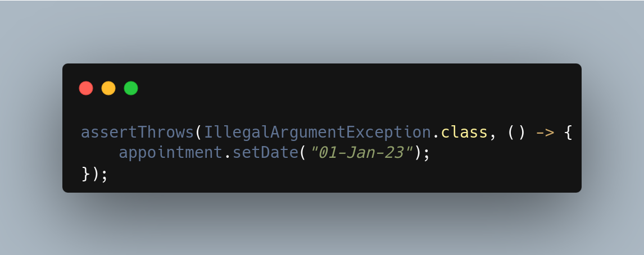

This test made sures that any attempt to set a date before the current day is caught, maintaining the integrity of the appointment data. Such use of exception handling validation made sures that all business rules are properly enforced in the system.

Code Efficiency

I had efficiency in my tests by avoiding redundant checks and by grouping related test cases. For example, in TaskTest, the test cases for setting invalid names are consolidated using different invalid inputs in a single test:
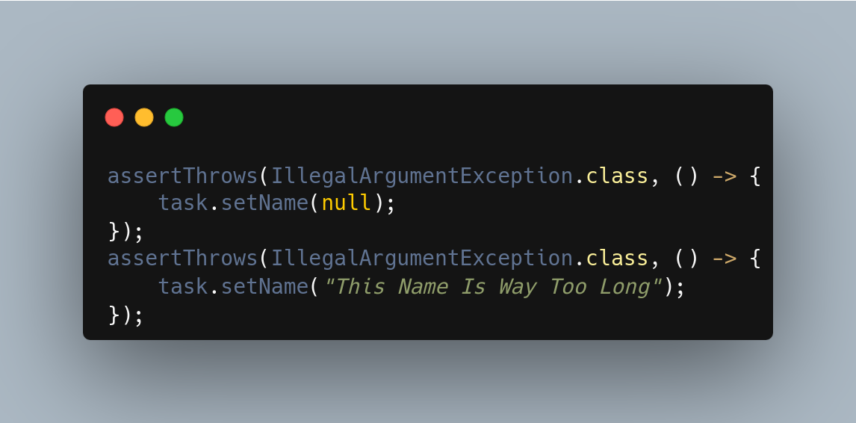
By combining similar invalid input tests, I avoided creating multiple test cases for each individual scenario, thus reducing redundancy while maintaining comprehensive test coverage.
Although, reflecting on this technique, it may have not been as effective as I wanted. When working with a Python testing library Thursday I discovered that chaining multiple tests did not have the desired outcome. In the Python package unittest I found out that once the first test was passed, it would skip every other chained test an pass the whole function. I have not tested if JUnit works the same way, but it would be worth a check.

Testing Techniques

Software Testing Techniques Employed

In the project, I really only used unit testing. Unit testing is the process of isolating and testing individual methods and functions in classes to made sure they work as expected (PractiTest, 2024). This approach allowed me to validate each feature (appointments, contacts, tasks) in isolation, making sure that each method adhered to the specific business rules. For instance, I used assertion techniques like assertEquals() and assertThrows() to validate both the correctness of the method outputs and the proper handling of invalid inputs.

Other Testing Techniques Not Used

I did not use integration testing or system testing in this project. Integration testing focused on testing the interaction between different components, making sure that they work together as expected. System testing validates the entire system's behavior as a whole (Davu, 2020). These testing techniques are useful in larger-scale projects or when different modules need to interact, but for this specific project, unit testing was good enough to meet the requirements.

Practical Uses and Implications

Unit testing is pretty useful for making sure that the correctness of individual features in isolation, which is critical for maintaining code quality during active development. However, for projects involving multiple interacting components, integration testing would be necessary to made sure that individual modules work together seamlessly. System testing, on the other hand, becomes important when validating the entire system's behavior in production-like environments, especially for customer-facing applications where reliability is very important (Davu, 2020).

Mindset

Caution and Complexity

Throughout the project, I used a cautious mindset, recognizing the complexity and interrelationships between the various service classes and entity classes. For example, in AppointmentService, the validation of duplicate IDs needed to be carefully tested because a failure in this check could lead to duplicate records, which would compromise the system's integrity. By being thorough in my tests, I lessened the potential issues that could arise from complex interactions within the data model.

Limiting Bias in Code Review

To limit bias in reviewing my code, I kept revising the requirements to made sure that my tests were driven by the software specifications rather than assumptions I made as a developer. I tried to keep the tests as similar to each class ass possible, but had to make some changes between then, like testing dateTime for some and phone-numbers for the other. Bias could easily become a concern if developers test their own code, as they might subconsciously overlook edge cases or assume certain functionality is correct without thorough validation.

Discipline in Commitment to Quality

Being disciplined in my commitment to quality meant not cutting corners, even when writing repetitive or seemingly redundant tests. I made sure that each validation rule was thoroughly tested, even for trivial features like name and description length. Cutting corners during testing can lead to technical debt, where unresolved issues accumulate over time and eventually impact the system's stability. To avoid this, I plan to maintain rigorous testing practices and regularly refactor code to made sure it stays maintainable and free of hidden issues. For example, moving toward more automated testing frameworks will help me avoid technical debt by catching potential issues early on in the development cycle.

References
PractiTest Team. (2024, September 19). Unit Test vs Integration Test Important Differences | PractiTest. PractiTest. https://www.practitest.com/resource-center/article/unit-test-vs-integration-test/
Davu, S. (2020, April 13). The four levels of software testing | Segue Technologies. Segue Technologies. https://www.seguetech.com/the-four-levels-of-software-testing/

